Calvary Community Center
4740 Baltimore Avenue
Philadelphia, PA 19143

RENEWAL APPLICANTS
CEDAR PARK NEIGHBORS SCHOLARSHIP APPLICATION 2018-2019
DEADLINE TO APPLY: June 15, 2018, 5 p.m.

IMPORTANT NOTE: You must live within the boundaries of Cedar Park in order to apply! Cedar Park is bounded by 46th Street, Kingsessing Avenue, the R-3 tracks, 52nd Street, and Larchwood Avenue (see map below). Contact the Scholarship Application Committee at scholarships@cedarparkneighbors.org if you have any questions about your eligibility.

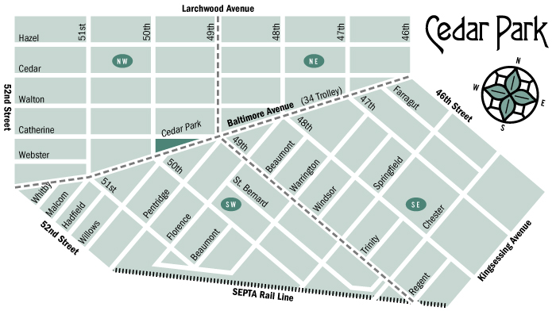

Application Instructions: Combine all application components, in the order of the checklist below, in a SINGLE PDF file. If an application component is not available before the application deadline (such as your Fall 2018 roster), you must include in its place a statement of when it will be available. Send completed application to scholarships@cedarparkneighbors.org by June 15, 2018, 5 p.m. Applications without all components included or accounted for by a statement (as described above) will be denied. Applications received after June 15, 2018 at 5 p.m. EST will also be denied. See Step-by Step Application Instructions on the final page of this application.

DEADLINE TO APPLY: June 15, 2018, 5 p.m. EST
If an application component is not available before the application deadline (such as your Fall 2018 roster), you must include in its place a statement of when it will be available. Applications without all components included or accounted for by a statement (as described above) will be denied. Applications received after June 15, 2018 at 5 p.m. EST will also be denied.

Applicant Information

LAST NAME: FIRST NAME: M.I.

STREET ADDRESS:

CITY/STATE/ZIP:

MUST BE: Philadelphia, PA 19143

CELL PHONE: HOME PHONE (IF APPLICABLE):

EMAIL ADDRESS:

NAME OF YOUR PARENT(S)/GUARDIAN(S):

POST-SECONDARY SCHOOL YOU WILL ATTEND (2018-2019):

COLLEGE MAJOR: | EXPECTED COLLEGE GRADUATION DATE:

Cedar Park Neighbors Scholarship Support Statement

I, ______________________________, agree to support efforts to generate funds for the Cedar Park Neighbors Scholarship program through the following efforts:

- Permitting the use of my name, photo, image or likeness to be used in advertising and marketing efforts to promote the fund. I realize that neither I nor relatives or others connected to me will benefit financially or otherwise from these promotional efforts.

- Providing updates on my academic progress when requested, during the period that I am accepting funds from the Cedar Park Neighbors Scholarship Fund.

- Participating in fundraising efforts for the scholarship fund as a student and as a college graduate through writing articles, making appearances, and participating in other activities the Cedar Park Neighbors deem appropriate to the extent possible.

_____________________________ _____________________________ ______________
(Student’s Signature) (Student’s Name-Printed) (Date)

Application Checklist

PLEASE SUBMIT APPLICATION COMPONENTS in the following order:
Points will be deducted for components not in order of this checklist.

- Applicant Information page (above)
- A signed copy of the Cedar Park Neighbors Scholarship Support Statement (above) and this checklist
- Application Narrative:
- Type a 500-word article for the CPN newsletter and/or thank-you letter to the CPN community that discusses your college experience so far, your accomplishments, and how the CPN Scholarship has helped you.
- Discuss the 2 CPN-related activities in which you participated this scholarship year. Activities can include:
- Attending the Awards Ceremony during the summer
- Attending the Winter Reception during winter break
- Attending the fundraiser at Dock Street (or contributing to the planning in some way)
  - Participating in the holiday food basket drive
- Delivering CPN newsletter to residents (if local)
- Participating in a Cedar Park clean-up day
- Optional: any additional writing that tells us what might set you apart from other applicants and what a CPN Scholarship would mean to you!

- An updated resumé that includes your school activities, school and community volunteer experiences, work experiences, career goals, references, internships, etc. The resume must be typed.
- A copy of your most recent college transcript (may be unofficial).
- A copy of a course roster for the Fall 2018 semester at a regionally accredited post-secondary school.
- A copy of your FAFSA Student Aid Report (NOTE: This item will be deleted after award decisions are made.)

Step-by-Step Application Instructions

1. Check the map above to confirm that you live within the stated boundaries and are eligible to apply.

2. Gather and write all required elements of the application. If an application component is not available before the application deadline (such as your Fall 2018 roster), you must include in its place a statement of when it will be available.

3. Put all application components into a single pdf file in the order of the checklist above. If you do not have access to Adobe Acrobat on a computer, you can find a number of free tools to assist you. Online, you can find free programs (like https://www.altomerge.com/). If you have a mobile device, you can download free apps (often called pdf scanners) that will enable you to take pictures of a document and turn it into a pdf.

4. Double-check that all required documents, or statements explaining when a document will be available, are in the correct order, outlined in the Application Checklist above. Points will be deducted for components not in order of the checklist above.

5. Name the single pdf with [YourLastName]CPNapp.pdf (for example: SmithCPNapp.pdf).

6. Send the document via email to scholarships@cedarparkneighbors.org before June 15, 2018, 5 p.m. EST. Applications without all components included or accounted for by a statement (as described above) will be denied. Applications received after June 15, 2018 at 5 p.m. EST will also be denied.

7. You will receive an email confirming receipt of your application. Scholarship winners will be announced before July 13, 2018.

QUESTIONS? Contact the Scholarship Application Committee at scholarships@cedarparkneighbors.org

