Calvary Community Center
4740 Baltimore Avenue
Philadelphia, PA 19143

NEW APPLICANTS

Application for students who have never received a CPN scholarship.
CEDAR PARK NEIGHBORS SCHOLARSHIP APPLICATION 2021-2022
DEADLINE TO APPLY: June 15, 2021, 5 p.m. ET

IMPORTANT NOTE: Applicants must live within the boundaries of Cedar Park in order to apply! Cedar Park is bounded by 46th Street, Kingsessing Avenue, the R-3 tracks, 52nd Street, and Larchwood Avenue (see map below). Applicants must certify that they live within these boundaries (except when in residence on / near campus). Contact the Scholarship Application Committee at scholarships@cedarparkneighbors.org if you have any questions about your eligibility.

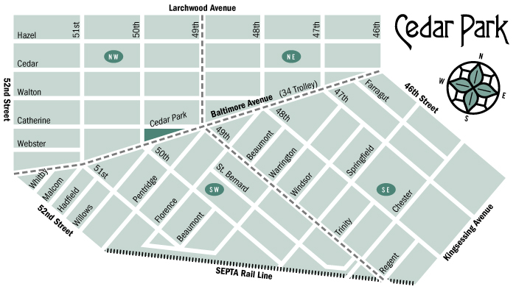

Application Instructions: Combine all application components, in the order of the checklist below, into a SINGLE PDF file. If an application component is not available before the application deadline (such as your Fall 2021 class roster), you must include in its place a statement of when it will be available. Send completed application to scholarships@cedarparkneighbors.org and contact this email with any questions. Applications without all components included or accounted for by a statement (as described above) will be denied. Applications must be written and submitted solely by the applicant (student). See Step-by Step Application Instructions on the final page of this application.

DEADLINE TO APPLY: June 15, 2021, 5 p.m. ET by email (no hard copies accepted). Applications received after June 15, 2021, 5 p.m. ET will be denied.

Applicant Information

LAST NAME: FIRST NAME: M.I.

LOCAL STREET ADDRESS:

CITY/STATE/ZIP:

MUST BE: Philadelphia, PA 19143

CELL PHONE: HOME PHONE (IF APPLICABLE):

EMAIL ADDRESS:

NAME OF YOUR PARENT(S)/GUARDIAN(S):

HIGH SCHOOL OR COLLEGE YOU ATTEND AND ACTUAL/ANTICIPATED GRADUATION DATE:

POST-SECONDARY SCHOOL YOU WILL TO ATTEND (2021-2022):

COLLEGE MAJOR: | ANTICIPATED COLLEGE GRADUATION DATE:

PLEASE TELL US HOW YOU FOUND OUT ABOUT THE SCHOLARSHIP PROGRAM:

□ School □ Family Member/Friend □ Current Scholarship Recipient □ Neighbor

□ Cedar Park Website □ Other: _____________________

Cedar Park Neighbors Scholarship Support Statement

I, ______________________________, certify that I live at the address above (when not at a campus residence during term time) and that it falls within the stated boundaries of the Cedar Park neighborhood. I agree to support efforts to generate funds for the Cedar Park Neighbors Scholarship program through the following efforts:

- Permitting the use of my name, photo, image or likeness to be used in advertising and marketing efforts to promote the fund. I realize that neither I nor relatives or others connected to me will benefit financially or otherwise from these promotional efforts.

- Providing updates on my academic progress when requested, during the period that I am accepting funds from the Cedar Park Neighbors Scholarship Fund.

- Participating in fundraising efforts for the scholarship fund as a student and as a college graduate through responding promptly to email inquiries by the committee, writing articles, making appearances, and participating in other activities the Cedar Park Neighbors deem appropriate to the extent possible.

Application Checklist

PLEASE SUBMIT APPLICATION COMPONENTS in the following order:
Points will be deducted for components not in order of this checklist.

- Applicant Information page (above)
- A signed copy of the Cedar Park Neighbors Scholarship Support Statement (above) and this checklist
- Applicant Narrative: Respond to each one of the following prompts in 5-10 sentences.

1. The thing that I like best about my Cedar Park community is….

2. If I could improve one thing about my Cedar Park community I would…

3. Describe a meaningful volunteer experience or an activity you participated in during high school or college and why it was important to you.

4. What will you use the CPN Scholarship for?
*Optional: any additional writing that tells us what sets you apart and what a CPN Scholarship would mean to you!
- A resumé that includes your high school and/or college activities, school and community volunteer experiences, work experiences, career goals, and references. The resume must be typed.
- A copy of your most recent high school transcript or copies of final report cards from each year of high school OR your most recent college transcript and/or most recent set of grades that can be verified as official by the college.
- Proof of acceptance to, and enrollment in, a regionally accredited post-secondary school.
- A letter of recommendation from a community leader (religious leader, block captain, teacher, counselor, scoutmaster, employer, etc. – not a family member) demonstrating your commitment to improve life in our neighborhood.
- A copy of your FAFSA Student Aid Report (NOTE: This item will be deleted after award decisions are made.)

Step-by-Step Application Instructions

1. Check the map above to confirm that you live within the stated boundaries and are eligible to apply. Applicants must live within these boundaries when not at a campus residence during term time. If a student splits time between the residences of two guardians, the student must live within the Cedar Park boundaries over 50% of the time.

2. Gather and write all required elements of the application. If an application component is not available before the application deadline (such as your Fall 2021 roster), you must include in its place a statement of when it will be available.

3. Put all application components into a single pdf file in the order of the checklist above. If you do not have access to Adobe Acrobat on a computer, you can find a number of free tools to assist you. Online, you can find free programs (like https://www.altomerge.com/). If you have a mobile device, you can download free apps (often called pdf scanners) that will enable you to take pictures of a document and turn it into a pdf.

4. Double-check that all required documents, or statements explaining when a document will be available, are in the correct order, outlined in the Application Checklist above. Points will be deducted for components not in order of the checklist above.

5. Name the single pdf with [YourLastName]CPNapp.pdf (for example: SmithCPNapp.pdf).

6. Send the document via email to scholarships@cedarparkneighbors.org before June 15, 2021, 5 p.m. ET. Applications without all components included or accounted for by a statement (as described above) will be denied. Applications received after June 15, 2021, 5 p.m. ET will also be denied. Applications must be written and submitted solely by the applicant (not a family member or mentor). No hard copies of the application will be accepted.

7. You will receive an email confirming receipt of your application. Scholarship winners will be announced by July 15, 2021.

QUESTIONS? Contact the Scholarship Application Committee at scholarships@cedarparkneighbors.org

